|  |  |  |
| --- | --- | --- |
| March 25, 2018  St. John the Baptist Church, Osgood  **& the Catholic Cohort of Immaculate Conception, St. Maurice, St. John**  *Three unique parishes joined in mutual support to live and spread the gospel, provide enhanced worship* *opportunities, further faith formation, welcome and reach out in love to those in need. (Cohort Mission Statement)* | | |
| **St. Maurice**  Napoleon | **Immaculate Conception**  Millhousen | **St. John the Baptist**  Osgood |
| **Sister Shirley Gerth, OSF**  Parish Life Coordinator  PO Box 17, Napoleon  Phone: 812-852-4237  or 812-621-7420  Web: [www.stmauricechurch.org](http://www.stmauricechurch.org)  e-mail:srsgerth@hotmail.com    For **Religious Education** classes  call Patty Simon: 812-689-4100  For **Youth Ministry** events call  Joyce Muckerheide: 812-363-5929 | **Sister Donna Prickel, OSF**  Parish Life Coordinator  2081 E Co. Rd 820 S, Greensburg  Phone: 812-591-2362/513-410-2600  Web: www.millhousenchurch.com  e-mail: sisterdonna@millhousenchurch.com  kathy@millhousenchurch.com  For **Faith Formation** classes  call Kathy Westrick: 812-591-2433  For **Youth Ministry** events call  Sharon Mapes: 812-591-4194 | **Sister Shirley Gerth, OSF**  Parish Life Coordinator  331 S Buckeye Street, Osgood  Phone: 812-689-4244  or 812-621-7420  Web:  stjohncatholicchurchosgood.com  e-mail: [srsgerth@hotmail.com](mailto:srsgerth@hotmail.com)  For **Religious Education** classes  call Patty Simon: 812-689-4100  For **Youth Ministry** events call  Jill Jansing: 812-689-4830 |
| **Sacramental Ministers:** **Father John Geis** and **Father William Turner**. | | |
| Saturday **Mass**: 4:00 PM  Sunday **Mass**: 10:00 AM  Sacrament of  **Reconciliation**  Saturday: 3:30-3:45 PM  Sunday: 9:30-9:45 AM | Sunday **Mass**: 8:00 AM  Sacrament of **Reconciliation**  Sunday: 7:30-7:45 | Saturday **Mass**: 6:00 PM  Sunday **Mass**: 12:00 noon  Sacrament of **Reconciliation**  Saturday: 5:30-5:45PM  Sunday: 11:30-11:45 AM |
| **Sacrament of Baptism** is scheduled by appointment.  Please call the parish office about sacramental preparation and to schedule your celebration.  Preparation for the Sacrament of **Marriage** requires at least six months.  Call the parish office before setting the date for your wedding.  Sacrament of **Anointing** is available upon request. | | |

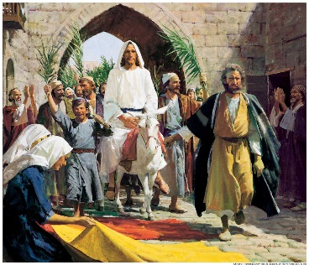

**MASS OF THE LORD'S SUPPER**

**St. Maurice Church, 6:00 PM**

**GOOD FRIDAY SERVICE**

**St. John Church, 4:00 PM**

**HOLY SATURDAY, EASTER VIGIL**

**St. Maurice Church 7:30 PM**

**EASTER SUNDAY, MASS OF RESURRECTION**

**Regular Sunday Schedule**

March 25, 2018

Palm Sunday

**Hosanna in the Highest**

**Look!**

**Before**

**and behind,**

**crying "Hosanna,**

**hosanna in the highest."**

**The crowds spread their cloaks,**

**cut down leafy branches from the fields,**

**making the way for you to enter Jerusalem.**

**Hosanna! Jesus of Nazareth, eternal joy.**

**Our God, walking along beside us,**

**our Lord who leads us to grace,**

**our king crowned with thorns,**

**our beloved, our hero,**

**loving us all the**

**way to the**

**cross.**

**Come into our hearts!**

**Hosanna!**

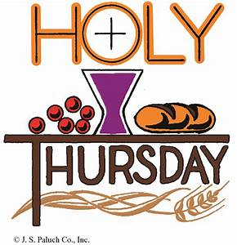

**HOLY THURSDAY**

**Unconditional Love**

**"We should glory in the Cross of our Lord Jesus Christ."**

**On Holy Thursday we begin the liturgy of Holy Week, the Paschal Triduum, which commemorates the living memorial of the institution of the Eucharist. Jesus bends down to wash the feet of all disciples, to demonstrate His unconditional love for us and the height and the depth of that love, a love that reaches even to death.**

**Go, do this in memory of me! (Text, Michael R. Prendergast, Oregon Catholic Press)**

**SUNDAY REFLECTIONS**

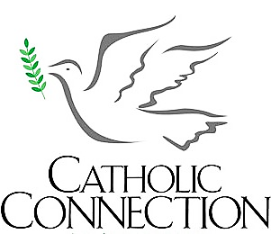**CONNECTION**

There were no limos waiting for Pope Francis during his U.S. visit in 2015. Instead, the pope chose to ride in a humble, black Fiat. Although he seemed a bit crowded, crammed into the back seat of the car, his humility touched the crowds who cheered his arrival.

In fulfillment of Zechariah’s prophecy, Jesus entered Jerusalem riding on a borrowed colt. People hailed him as the king who comes in the name of the Lord. Although many hoped he would overthrow the Roman occupation, Jesus did not come as a king riding a mighty war horse. Instead, he sat on a small colt. The welcoming throngs paved the way with their cloaks and palms and filled the air with their cheers of greeting.

**INCLUDING YOUTH**

 Imagine you were somehow assigned to a second grade math class. Within minutes, maybe seconds, you would tune out. Inside your mind, you would keep thinking: “I know this, I know this, I know this! Why do I have to go through it again?” And you would be right. But the story of Jesus’ passion is not second grade math facts. It is inspired Scripture. If we open our mind to it, we will never exhaust it.

Peter screwed up badly! Cursed and swore he did not even know Jesus. How could he ever hold his head up again? Well, he did. Knowing he was forgiven enabled him to overcome his shame. We should remember Peter when we screw up and feel ashamed.

**PLEASE NOTE: NO ADORATION Of The BLESSED SACRAMENT on Wednesday, March 28 at St Maurice. Instead it will be the following evening, Holy Thursday, March 29 after Mass until 8:00 PM.**  There will be no Adoration of the Blessed Sacrament on Good Friday morning at St. Maurice or on Holy Saturday morning at St. John.

**MEMORIALS** - $190.00 was received for St. John Cemetery in memory of Julie Kappes. We are grateful for this gift.

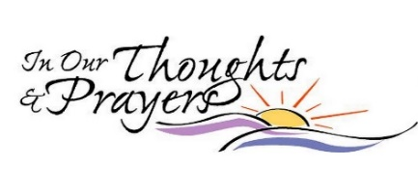

Carl Wagner Urban Johannigman

Phil Wittich Joe Kelly

Pat Grieshop Linda Bear

Evelyn Nimeskern Simon C Allison

Henry Peters Drew Willa

Donnie Hoffrogge M/M/ Tom Murray

Glenna Ward Kelly Spiller

Amy Castner Katie Smith

Todd Castner Mary Bruns

Jeff Newhart Katie Warner

Brenda Wetzler Gerald Hermesch Natalie Brown Gary Payne

Madeline Ronaldson Molly Ronaldson Ruth Kieffer

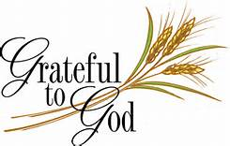**PARISH SUPPORT**

**Sunday Collection $ 2,904.01**

**Votive Candles 45.20**

**“God is GOOD!”**

**THE PONTIFICAL GOOD FRIDAY COLLECTION**

Pope Francis has asked our parish to support the Pontifical Good Friday Collection, which helps Christians in the Holy Land.

Your support helps the church minister in parishes, provide Catholic schools and offer religious education. The Pontifical Good Friday Collection also helps to preserve the sacred shrines.

***Please be generous***



**Saturday, March 24, 6:00 PM**

**+** Cletus & Rosella Holzer

**Sunday, March 25, 12:00 Noon**

+ Diane Earls

**Holy Thursday, March 29**

**+** Meister Family

**Easter Sunday, April 1, 12:00 Noon**

+ Carl Wenning

**MINISTRY SCHEDULE**

**Good Friday, March 30, 4:00 PM**

Coordinator Ron Miller

Lector Andy Miller

(Lector/Narrator)

Sharon Voegeli (Other)

Greeters Ron Miller/Lois Lunsford

Servers Peyton Owens

Aaron Greiwe

**Easter Sunday, April 1, 12:00 Noon**

Coordinator Jeff Greiwe

Lector Jane O’Grady

Greeters Jeff Greiwe

Bob Voegeli

Servers Aaron Greiwe

Eucharistic Jessica Gorman

Ministers Ron Ebinger

**RELIGIOUS EDUCATION**

There will be NO Religious Education classes for **Grades 6-12** on Palm Sunday, March 25 and Easter Sunday, April 1. The next class will be April 8.

**Children in Grades Pre School through Grade 5** - Your next class is Wednesday, April 4, 6:45 PM. There will be no classes on March 28.

**PASSION PLAY**The Passion Play by the 5th and 6th grade classes has been rescheduled for Wednesday, April 4, 7:00 PM.  There will be NO meal for the children that evening.  Also it will be the last night "pennies" and "rice bowls" to be brought in by the children.

**GOLDEN GATE CHOIR -** The Golden Gate Choir will present **"Hope Lives in Me"**, a Palm Sunday/Easter cantata, on Sunday, March 25, 7:00 PM at the Damm Theatre, Osgood. A free will offering is gratefully accepted.

March 25, 2018 – Local News & Events

Adoration of Blessed Sacrament

**HOLY WEEK SERVICES**

**Holy Thursday**

6:00 PM at St Maurice

6:00 PM at Immaculate Conception

**Good Friday**

4:00 PM at St John

4:00 PM at Immaculate Conception

**Holy Saturday**

7:30 PM at St Maurice for all parishes

**Easter Sunday**

Regular Sunday Mass Schedule

Holy Thursday, March 29 at St Maurice

After Mass until 8:00 PM

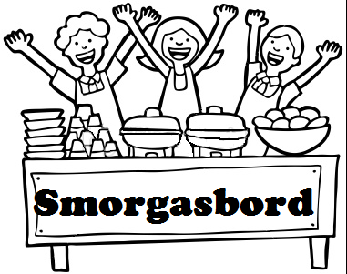

St Maurice Catholic Church

Saturday, April 14

4:00 to 7:30 PM

Adult - $10

Children (6-12) - $5

Carry-Out ($10.50)

Menu Includes – Roast Beef, Turkey & Dressing,

Meatloaf, Spaghetti, German Potato Salad, Sauerkraut,

Salads, Homemade Desserts

Deanery & Beyond Events

**FISH FRYS**

St Mary, Aurora Good Friday, March 30 4:00 to 7:30

Millhousen Knights of St John March 30 5:00 to 7:30

**St. Charles (Milan) March 30      4:00 to 7:00**

**Proceeds will go to Fr. Frank Eckstein and Gibault Children’s Services**

**St Paul’s Luther Church, Batesville** Chicken & Beef Supper, Saturday, April 7 4:30 to 7:30

**New Alsace American Legion** Sausage & Pancake Breakfast. Sunday, April 8, 7:30 to Noon

**Millhousen Knights of St John** – Sausage & Pancake Breakfast, Sunday, April 8, 8 to 11 AM. Millhousen Knights Hall. Free Will Offering.

**Seasons of Hope** A group for the bereaved. St Mary’s Greensburg. Tuesdays beginning April 2. 6:30 to 8:30 PM, Church Meeting Room. Please register before March 23. 812-663-8427.

**Our Lady of Fatima Retreat House** Contact 317-545-7681.

**Sunday, March 25 – Palm Sunday *Stations of the Cross -* 3:00-3:45 pm – Traditional ‘Way of the Cross’ on our trails, weather permitting.** Join Fr. Keith Hosey as we celebrate our trails being open again this year.  If not, we will use the stations inside of our chapel. Please RSVP by calling [317-545-7681](tel:(317)%20545-7681)

**4:00- 5:15 pm – *Contemporary Stations of the Cross*** All are welcome! Please RSVP by calling [317-545-7681](tel:(317)%20545-7681)

**Life Walk 2018 (Pregnancy Care Center of SE Indiana)** – April 21 at the Ivy Tech Community College, 50 Walnut St, Lawrenceburg. 8:30 AM Registration, 9:00 Walk Begins. We are depending on the funds raised to continue offering our services and to minister to men and women that He will send our way this year. 812-537-4357 or www.supportpccindiana.org.

**St Nicholas (Sunman) Turtle Soup (& Chicken Noodle Soup) Supper**. April 21, 4:00 to 8:00 PM. Fish & Pulled Beef sandwiches, pies & cakes, games for the family, raffle. Stnicholas-sunman.org, 812-623-2964

**CYO Camp Rancho Framasa** – Your Archdiocesan Summer Camp. Contact: 888-988-2839 or campranchoframasa.org. Questions? [Angie@campranchofframasa.org](mailto:Angie@campranchofframasa.org). Catholic Camping Makes a Difference! Now Hiring for Summer Camp Positions. **Women’s Only Weekend (Wow) April 20-21; for those 21 and older. Spring Family Camp May 11-13; best suited for those 5 and older. Mother Daughter’s Spring Weekend May 4-6; 5 yrs and older. Summer Camp June 3-July 27; for those 5-18.**