|  |  |  |
| --- | --- | --- |
| June 10, 2018  St. John the Baptist Church, Osgood  **& the Catholic Cohort of Immaculate Conception, St. Maurice, St. John**  *Three unique parishes joined in mutual support to live and spread the gospel, provide enhanced worship* *opportunities, further faith formation, welcome and reach out in love to those in need. (Cohort Mission Statement)* | | |
| **St. Maurice**  Napoleon | **Immaculate Conception**  Millhousen | **St. John the Baptist**  Osgood |
| **Sister Shirley Gerth, OSF**  Parish Life Coordinator  PO Box 17, Napoleon  Phone: 812-852-4237  or 812-621-7420  Web: [www.stmauricechurch.org](http://www.stmauricechurch.org)  e-mail:srsgerth@hotmail.com    For **Religious Education** classes  call Patty Simon: 812-689-4100  For **Youth Ministry** events call  Joyce Muckerheide: 812-363-5929 | **Sister Donna Prickel, OSF**  Parish Life Coordinator  2081 E Co. Rd 820 S, Greensburg  Phone: 812-591-2362/513-410-2600  Web: www.millhousenchurch.com  e-mail: sisterdonna@millhousenchurch.com  kathy@millhousenchurch.com  For **Faith Formation** classes  call Kathy Westrick: 812-591-2433  For **Youth Ministry** events call  Sharon Mapes: 812-591-4194 | **Sister Shirley Gerth, OSF**  Parish Life Coordinator  331 S Buckeye Street, Osgood  Phone: 812-689-4244  or 812-621-7420  Web:  stjohncatholicchurchosgood.com  e-mail: [srsgerth@hotmail.com](mailto:srsgerth@hotmail.com)  For **Religious Education** classes  call Patty Simon: 812-689-4100  For **Youth Ministry** events call  Jill Jansing: 812-689-4830 |
| **Sacramental Ministers:** **Father John Geis** and **Father William Turner**. | | |
| Saturday **Mass**: 4:00 PM  Sunday **Mass**: 10:00 AM  Sacrament of  **Reconciliation**  Saturday: 3:30-3:45 PM  Sunday: 9:30-9:45 AM | Sunday **Mass**: 8:00 AM  Sacrament of **Reconciliation**  Sunday: 7:30-7:45 | Saturday **Mass**: 6:00 PM  Sunday **Mass**: 12:00 noon  Sacrament of **Reconciliation**  Saturday: 5:30-5:45PM  Sunday: 11:30-11:45 AM |
| **Sacrament of Baptism** is scheduled by appointment.  Please call the parish office about sacramental preparation and to schedule your celebration.  Preparation for the Sacrament of **Marriage** requires at least six months.  Call the parish office before setting the date for your wedding.  Sacrament of **Anointing** is available upon request. | | |

June 10, 2018

Tenth Sunday in Ordinary Time

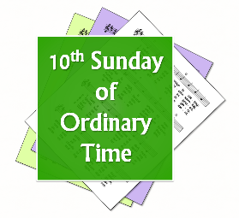

**Here are my Mother and my Brothers.**

**Jesus,**

**is it what**

**you came to do?**

**Make us your family?**

**We are all your sisters and brothers**

**as we do the will of your**

**Father.**

**We know Him**

**because we know You.**

**Give us the grace**

**to love Him, and**

**the desire**

**to do**

**the will**

**of Our Father.**

**(Copyright 2018, Anne M. Osdieck. Used with Permission)**

**SET YOUR FAITH ON FIRE**

**... A person has helped set my faith on fire by stepping forward to welcome immigrants and refugees into their community and then reaches out to give whatever help is needed.**

**... My faith is strengthened by several families I know who refused to institutionalize a mentally handicapped baby and that baby ended up becoming the light of their lives by innocence, simplicity and loving ways.**

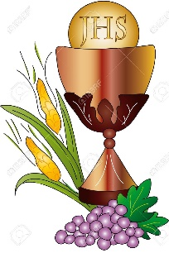***OUR FIRST COMMUNION CHILDREN***

***Aaden Dicken***

***Camdin Hodge***

***Emily McKittrick***

***Landon Werner***

***CONGRATULATIONS! BLESSED FIRST COMMUNION DAY!***

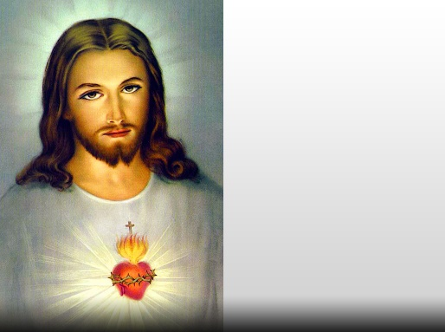

**MONTH OF THE SACRED HEART**

The month of June is dedicated to the mystery of the Sacred Heart. Fr. James Kubicki says in his book "A Year of Daily Offerings" that Jesus experienced all the movements of the sacred heart but because he is divine as well as human, he experienced them with divine intensity. His physical heart was pierced on the cross and blood and water, symbolizing the Eucharist and Baptism, gushed forth. The heart of Jesus is alive and beating with love for us. His heart pumps life into us. Sacred Heart of Jesus, I give myself to you!

**SUNDAY REFLECTIONS**

**CONNECTION**

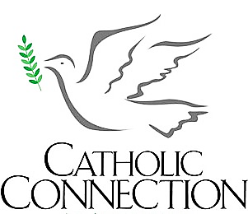 “You are out of your mind!” Has anybody ever said that to you? Or you to another person? No doubt most of us have heard or said this a time or two. If directed at us, we are in good company according to today’s Gospel. The relatives of Jesus said that about him when he came home. The reason for such judgement is not entirely clear. Is it because the crowds that followed him disrupted their way of life? Or was it because the scribes from Jerusalem were saying that he was possessed?

We might ask ourselves what might prompt us to respond in such a way. Is someone living the Gospel in a way that challenges us and we feel uncomfortable? Are we being asked to change in a way that we resist?

**SANTUARY LIGHT**

The Sanctuary Light burns from June 10 through June 16 for Robert Bartlowe.

**INCLUDING YOUTH**

 The point of nakedness in the Genesis story was not that sexual body parts are sordid or shameful. Remember the story says Adam and Eve were naked before sin entered the picture.

The writer of Genesis chose a symbol, both graphic and easily understandable, to illustrate the shame produced by conscience, telling us we have broken boundaries intended for our own good.

Today, the writer might have Adam suddenly realizing he was completely bankrupt after having sinned. Nothing wrong with money as such, just as with sex, but bankruptcy is not a comfortable feeling.



**Saturday, June 9, 6:00 PM**

**+** Art Simon

**Sunday, June 10, 12:00 Noon**

+ Robert Bartlowe

**Saturday, June 16, 6:00 PM**

**+** Cletus & Rosella Holzer

**Sunday, June 17, 12:00 Noon**

+ Emily Mathes

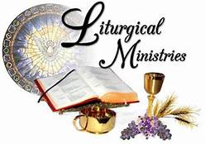

**Saturday June 16, 6:00 PM**

**Coordinator** Sharon Voegeli

**Lector** Nancy Obermeyer

**Greeters** Bob & Sharon Voegeli

**Servers** Wyatt & Briar McCain

**Wine Ministers** Stephanie Miller

John Holzer

**Sunday June 17, 12:00 Noon**

**Coordinator** Jeff Greiwe

**Lector** Jessica Gorman

**Greeters** Jeff Greiwe

Steve Mathes

**Servers** Aaron Greiwe

Peyton Greiwe

**Eucharist**

**Minister** Jessica Gorman



Carl Wagner Urban Johannigman

Phil Wittich Joe Kelly

Pat Grieshop Linda Bear

Evelyn Nimeskern Simon C Allison

Henry Peters Drew Willa

Donnie Hoffrogge M/M/ Tom Murray

Glenna Ward Kelly Spiller

Amy Castner Katie Smith

Todd Castner Mary Bruns

Katie Warner Brenda Wetzler

Gerald Hermesch Natalie Brown

Gary Payne Madeline Ronaldson Molly Ronaldson Ruth Kieffer

Phyllis Hellmich Peggy Lewis

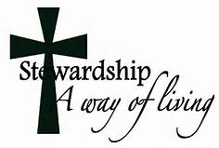**STEWARDSHIP**

Adam and Eve were banished from the Garden because of their disobedience. But Jesus says in today’s Gospel that when we are obedient to God’s will – when we use our gifts to serve one another – we are part of His family. “Whoever does the will of God is brother and sister and mother to me.” This is a gift, and fruit, of Baptism.



**PARISH SUPPORT**

**Sunday Collection $ 2,618.00**

**Votive Candles 35.00**

**“Your Gifts are Received with Gratitude!”**

**PARISH COUNCIL** Nominations for the Parish Council will take place the weekend of August 4- 5 and the Elections will occur the weekend of August 18 -19.



**ST JOHN LADIES BAKE SALE**

Thanks to all those who organized, worked at and purchased baked goods over the Memorial Day Weekend. The money collected will be donated to the Relay for Life.

June 10, 2018 – Local News & Events

Deanery & Beyond Events



**St Catherine of Siena** Parish Festival, June 24, St Maurice, Indiana. Mass at 10 AM. Pedal Tractor Pull, Live Music, Beer & Wine Garden. Serving Chicken & Roast Beef Dinners & Turtle soup. 10:30 AM to 4:00 PM

**ARCHDIOCESE OF INDIANAPOLIS, OFFICE OF MARRIAGE AND FAMILY LIFE**

**OFFICE OF HUMAN LIFE AND DIGNITY** **(**[www.archindy.org](http://www.archindy.org))

**June 26 – Hospice and Palliative Care Conference, 8:30 to 11:30 AM** - Marian University Evans Center, Cold Spring Road, Indianapolis. Sponsored by the Archdiocese of Indiana Franciscan Health & St Vincent Health.

**September 7, 9:00 AM to 3:00 PM. Health Ministry Retreat.** Volunteers who serve Health Ministry in the Parishes Day of Reflection & Rejuvenation. Oldenburg Retreat Center, Oldenburg, Indiana.

**ATTENTION ALL MARRIED COUPLES CELEBRATING**

**50 YEARS OF MARRIAGE IN 2018!**

You are invited to the 35th Annual Gold Wedding Jubilee! The celebration takes place on August 5, 2018 at 2:00 PM at the SS. Peter and Paul Cathedral with Mass celebrated by Archbishop Charles Thompson. The Mass will be followed by a reception across the street. The event is free, but registration is required. Marriage and Family Life on archindy.org.



**Oldenburg Franciscan Center**

**Retreat, Renew, Rejoice**

**(**[**center@oldenburgosf.com**](mailto:center@oldenburgosf.com)**)**

Lunch & Learn, Cultivating a Garden of Grace. Tuesday, June 12, 11:30 AM to 1:00 PM. $20 includes lunch. Gardening offers a multitude of benefits for the earth and the soul. Come share a time of spiritual enrichment as we advance in cultivating gardens of grace in our yards and in our hearts.

Praying With Your Smartphone, Thursday, June 14th, 6:30 PM to 8:00 PM. Call 812-933-6437 to pre-register.

Explore how technology can help you pray and grow spiritually. This will be a hands-on workshop so bring your phones and/or tablets.

Film, Faith & Franciscanism, Friday, June 22, 6:30 PM to 9:00 PM. Freewill Donation. *Meant To Be*, Nathan questions his purpose in life and decides to track down Linda, his birth mother. She has felt guilty about giving up Nathan, and she tries to help a teenage mother who is conflicted about her pregnancy.

Francis, Creation Spirituality & John Denver, Saturday, June 23, 9:30 AM to 2:30 PM. $45 includes lunch. Call 812-933-6437 to pre-register. Both St Francis of Assisi and John Denver and God in the beauty and wonder of Creation. Through the music and lyrics of John Denver, this workshop will explore creation centered spirituality and our response to Creation through prayer and reflection.

Batesville Deanery Corner – Resource Center [www.batesvilledeanery.com](http://www.batesvilledeanery.com) 18 W St Louis place, wed & thur 1 to 6 PM or by appointment (812-932-0789)