|  |  |  |
| --- | --- | --- |
| July 23, 2017  St. John the Baptist Church, Osgood  **& the Catholic Cohort of Immaculate Conception, St. Maurice, St. John**  *Three unique parishes joined in mutual support to live and spread the gospel, provide enhanced worship* *opportunities, further faith formation, welcome and reach out in love to those in need. (Cohort Mission Statement)* | | |
| **St. Maurice**  Napoleon | **Immaculate Conception**  Millhousen | **St. John the Baptist**  Osgood |
| **Sister Shirley Gerth, OSF**  Parish Life Coordinator  PO Box 17, Napoleon  Phone: 812-852-4237  or 812-621-7420  Web: [www.stmauricechurch.org](http://www.stmauricechurch.org)  e-mail:srsgerth@hotmail.com  For **Religious Education** classes  call Patty Simon: 812-689-4100  For **Youth Ministry** events call  Joyce Muckerheide: 812-363-5929 | **Sister Donna Prickel, OSF**  Parish Life Coordinator  2081 E Co. Rd 820 S, Greensburg  Phone: 812-591-2362/513-410-2600  Web: www.millhousenchurch.com  e-mail: sisterdonna@millhousenchurch.com  kathy@millhousenchurch.com  For **Faith Formation** classes  call Kathy Westrick: 812-591-2433  For **Youth Ministry** events call  Sharon Mapes: 812-591-4194 | **Sister Shirley Gerth, OSF**  Parish Life Coordinator  331 S Buckeye Street, Osgood  Phone: 812-689-4244  or 812-621-7420  Web:  stjohncatholicchurchosgood.com  e-mail: [srsgerth@hotmail.com](mailto:srsgerth@hotmail.com)  For **Religious Education** classes  call Patty Simon: 812-689-4100  For **Youth Ministry** events call  Jill Jansing: 812-689-4830 |
| **Sacramental Ministers:** **Father John Geis** and **Father William Turner**. | | |
| Saturday **Mass**: 4:00 PM  Sunday **Mass**: 10:00 AM  Sacrament of  **Reconciliation**  Saturday: 3:30-3:45 PM  Sunday: 9:30-9:45 AM | Sunday **Mass**: 8:00 AM  Sacrament of **Reconciliation**  Sunday: 7:30-7:45 | Saturday **Mass**: 6:00 PM  Sunday **Mass**: 12:00 noon  Sacrament of **Reconciliation**  Saturday: 5:30-5:45PM  Sunday: 11:30-11:45 AM |
| **Sacrament of Baptism** is scheduled by appointment.  Please call the parish office about sacramental preparation and to schedule your celebration.  Preparation for the Sacrament of **Marriage** requires at least six months.  Call the parish office before setting the date for your wedding.  Sacrament of **Anointing** is available upon request. | | |

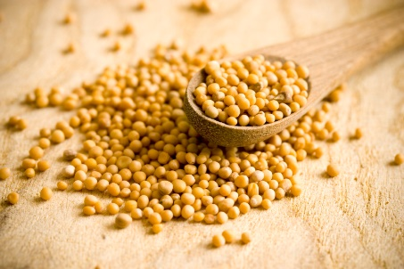

July 23, 2017

16th Sunday in Ordinary Time 

**16TH SUNDAY IN ORDINARY TIME**

**FIRST READING (Wisdom 12:13, 16-19)**

**Gentle God,**

**you teach, by Jesus' example,**

**that justice is kind,**

**that power**

**can be**

**mild.**

**Let us learn from you.**

**GOSPEL READING (Matthew 13: 24-43)**

**The smallest of all,**

**the mustard seed contains all**

**that the big mustard plant**

**could ever need.**

**Lord,**

**give us**

**one tiny grace.**

**It is enough for us.**

**SECOND READING (Romans 8:26-27**

**Holy Spirit,**

**dwelling in us,**

**take our trivial prayers,**

**weave them into your own.**

**When the Father searches our hearts**

**may He find your infinite acts of love**

**intertwined with our**

**small ones.**

**(Anne Osdieck, Celebration 2017)**

**SUNDAY REFLECTIONS**

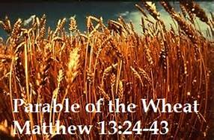Dolly Parton probably was not thinking about today’s Gospel when she said “The way I see it, if you want the rainbow, you gotta put up with the rain.” In the first parable today the farmer planted good wheat in his fields. His enemy tried to sabotage the crop by sowing weeds in the fields. The wise farmer decided to put up with the weeds until the harvest. Then he had the weeds removed. Afterward, with full barns he enjoyed the “rainbow” of the good harvest.

The Gospel teaches us that at the end of the world the evildoers will be hurled into the fiery furnace. The saints will shine like the sun in their Father’s kingdom.

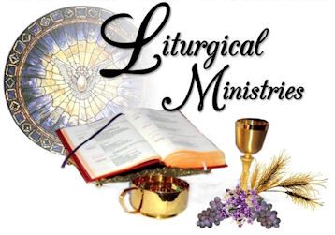

**Saturday July 29, 6:00 PM**

Coordinator Sharon Voegeli

Lector Sharon Voegeli

Greeters Bob Voegeli

Steve Mathes

Servers Ben Miller

Nick Miller

Eucharistic John & Teresa

Ministers Kappes

**Sunday, July 30, 12:00 Noon**

Coordinator Kevin Tunny

Lector Maurice Reardon

Greeters Kevin Tunny

Lois Lunsford

Servers Mike Schmitt

Samantha Colyer

Eucharistic Jessica Gorman

Ministers Kevin Tunny

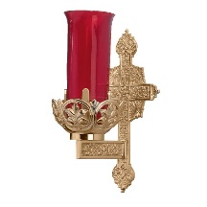**SANCTUARY LIGHT**

The Sanctuary Light burns from July 23 to July 29 for Diane Earls



**Saturday, July 22, 6:00 PM**

**+** Meister Sloan Family

**Sunday, July 23, 12:00 Noon**

+ Diane Earls

**Sunday, July 29, 6:00 PM**

+ Harold Huff

**Sunday, July 39, 12:00 Noon**

+ James McCain

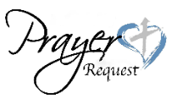

**PRAYER REQUESTS**

Evelyn Nimeskern Todd Castner

Henry Peters Urban Johannigman

Donnie Hoffrogge Joe Kelly

M/M/ Tom Murray Linda Bear

Janet Ward Simon C. Allison

Sue Herbert Kelly Spiller Drew Willa Amy Castner Katie Smith Mary Bruns

David Bedel Dottie Fullenkamp

Bonnie Franklin Gerald Hermesch Natalie Brown Casey Simon

Gary Payne Madeline Ronaldson Molly Ronaldson Katie Warner

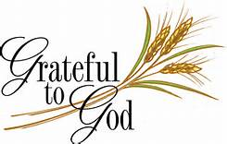

**PARISH SUPPORT**

**Sunday Collection $ 2,106.85 Votive Candles 42.50**

**“May All Your Gifts Be Acceptable to God!”**

**STEWARDSHIP**  “Those who are just must be kind,” says today’s first reading. If our words and deeds are kind and selfless, we will be like the good seed in the Gospel parable and gathered as wheat in the Lord’s harvest.

**INSTALLATION -** The Most Reverend Charles C. Thompson will be installed as the seventh Archbishop of Indianapolis this Friday, 2:00 PM at Ss. Peter and Paul Cathedral. Lord, send Your Spirit upon him as he ministers among us.

**PHOTOS FOR 150th CELEBRATION**

Our 150th Committee needs your help! If anyone has photos of any parish event or happening during the last 150 years of parish life, and are willing to lend them to us for the final celebration, we would be most grateful. Simply place your pictures in an envelope with your name and phone number. Place them in a box in the back of the church. These pictures will be used to create collages of photos from the past and present. Thank you.



**RCIA**  The Rite of Christian Initiation of Adults is for those who are interested in possibly joining the Catholic Faith; for those adults who have not been Confirmed but now desire this Sacrament; and those Catholics who are seeking to deepen their knowledge of the Catholic Faith.

Classes will begin the end of September and continue until Holy Week.

If you or someone you know would like to register for the classes have them call the parish office.

**THANK YOU FOR GIVING TO THE UNITED CATHOLIC APPEAL**

We are all called to share the gifts we have been given, just as God has been generous to us. For each of you who answered the call, giving to the United Catholic Appeal we say

*thank you!*

Our ministries will continue to thrive, thanks to your support. To see a thank you video go to www.archindy.org/UCA.